Infrastructure - Specification - Buffer Stops
For Passenger Carrying Services

CE-019-SP-0042
3.02
24/06/2026



Table of Contents:
1 PURPOSE 3
2 SCOPE 3
3 DEFINITIONS & ABBREVIATIONS 3
4 COMPLIANCE 3
5 ASSUMPTIONS 3
6 SPECIFICATIONS 4
6.1 Interface Requirements 4
6.2 Retardation and Acceleration Limits 4
6.3 Visibility and Coating Requirements 5
6.4 Structural Design of Butter Stop 6
6.5 Minimum Design and Manufacturing Information 6
7 RELATED LEGISLATION & DOCUMENTS 7
DOCUMENT VERSION CONTROL 7

PURPOSE
The purpose of this specification is to specify the minimum requirements for buffer stops within the Metropolitan Tram Network for passenger carrying tracks based on the Infrastructure - Tram Track Design Standard (CE-021-ST-0035) and Track and Structure – Tramway (PTV-NTS-007:2019).

SCOPE
The requirements of this specification shall be met to achieve the following:
- A buffer stop installation of less than 2.9m for retardation from 10km/h of all tram classes
- A buffer stop installation of less than 4.0m for retardation from 15km/h of all tram classes (utilising tram energy absorption).
- A buffer stop installation of less than 4.75m for retardation from 15km/h of all tram classes (not using tram energy absorption)

DEFINITIONS & ABBREVIATIONS
Word | Definition
41kg/m Rail | Rail profile as defined in STD_T9002(A)
NDT | Non-destructive testing
Ri57A | Rail profile as defined in STD_T9002(A), also referred to as Ri57A/R10

COMPLIANCE
This specification must be fully complied with.
Deviation from this specification is only permitted when a deviation or waiver has been formally requested and approved by the Engineering Design Authority at Yarra Trams.
The Yarra Trams Management of Change process must be followed in all circumstances where change is proposed to this specification.

ASSUMPTIONS
This is based on the following assumptions:
- That the final energy absorption for the above installation lengths for the E-Class and NGT (G) Class will involve the use of energy absorption devices on the rolling stock.
- That any installation will maximise installation length within the available space to ensure SFAIRP, but at a minimum will provide retardation from 10km/h.
- That a 10km/h installation covers 90% of recorded accidents on the Yarra Trams network and a 15km/h installation all known accidents.
- Within the compact dimensions of the network the preferred means to do this is the use of friction stop buffers in isolation due to the wide variation in height of the buffers on the tram fleet.

SPECIFICATIONS
The following general requirements are specified for the buffer stop design.

Interface Requirements
The following general requirements are specified for the buffer stop design.
- The buffer stop shall be capable of being installed onto either 41kg/m T-rail or grooved rail Ri57A/R10.
- The buffer stop shall be designed for safe operation in a street environment in Melbourne with a design life of 30-years. Major environmental factors in this environment to be taken into account during design include:
  - Coastal environment. i.e., saline moisture
  - Precipitation and hail.
  - High UV index.
  - High solar gain.
  - Minor impacts from automobiles.
- The impacting interface shall mimic the toothed profile of the existing trams fleets to minimise the potential for overriding. Yarra Trams will supply this information during the design phase.
- The buffer stop shall be compatible with A, B, C, D, E and Z class tram buffer configurations as per drawing and photographic information supplied by Yarra Trams.
Note: For example, a summary of buffer heights is provided in the following image.
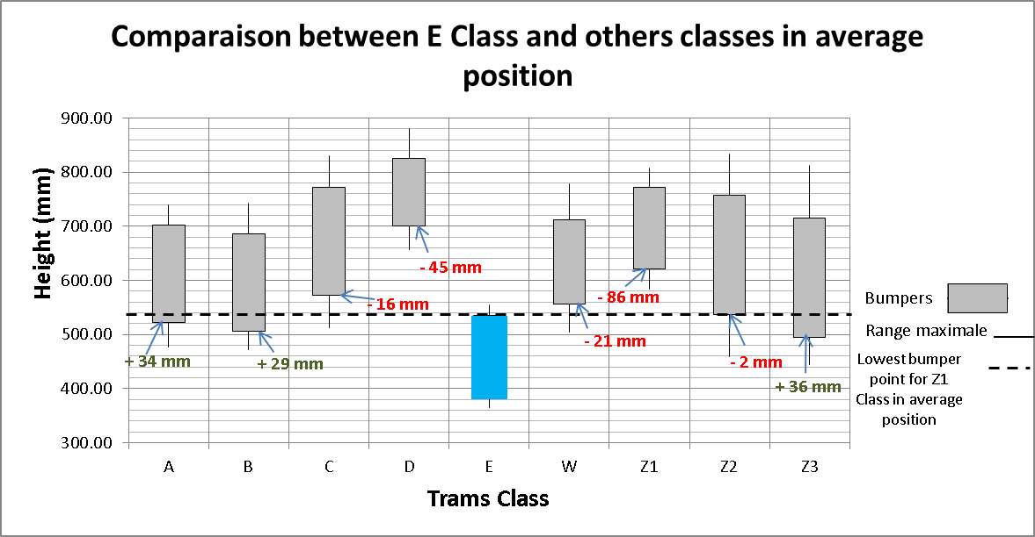
- The new NGT tram (G Class) will have bottom of buffer 370mm above rail level. This shall also be accounted for in the buffer design.
- The supplied buffer stop shall comply with the UNIFE “Prohibited and Restricted Substances List” at the time of contract. MSDS for all chemicals used in maintenance and all restricted substances shall be submitted to Yarra Trams for review and approval.

Retardation and Acceleration Limits
The following are specified in terms of retardation and acceleration limits:
- The installation lengths for 10km/h and 15km/h shall be as per the introduction to the specification.
- The maximum specified retardation force of 200kN shall only be exceeded for short durations, a fraction of a second, so as effectively not be seen by the rolling stock structure.
- Acceleration levels experienced by passengers shall be less than the limits in EN15227 “Rail applications – Crashworthiness requirements for railway vehicle bodies”.
- Collision masses utilised in simulation shall be as follows:
Tram Type | Tonnage (Tonne)
NGT Tram (G) | 56.8 and 40.4 tonnes
E Class | 49.5 tonne
C2 Class | 41.8 tonne
D2 Class | 37.33 tonne
C1 Class | 30.1 tonne
D1 Class | 27.15 tonne
B2 Class | 32.2 tonne
A Class | 23.7 tonne
Z3 Class | 23.375 tonne
Note: NGT assumes 76.5kg passenger mass as per contract all other values consider 75kg.
- Simulations shall be for unbraked rolling stock on level track.
- If additional rubber elements are to be fitted the buffer stop these shall be 4 off SEDITEC “Tampons amotrisseurs en polyurethane elastomere” 160mm-x160mm which mimics the absorption on the Citadis tram. These would be fitted for the higher bumper fleets.
- Approval by Yarra Trams of simulation results for the buffer stop is required before manufacturing can commence.

Visibility and Coating Requirements
The following general requirements are specified for the buffer stop design.
- The buffer stop shall have reflective markings on all four sides. The regime shall be as follows:
  - One each side except two at the impacted end.
  - Minimum reflective marker size shall be 75mm by 350mm, to ensure that both the oncoming tram and adjacent traffic can identify the buffer stop.
  - Reflective markers shall utilise a material Class 1A complaint to AS/NZS1906.2 or Class 1W to AS/NZS 1906.1.
- The impacting surface of the buffer stop shall be painted safety yellow (AS2700 yellow Y11 to Y15, Y22, Y23, Y26) or agreed equivalent.
- The area painted in safety yellow shall be a minimum of 1 square metre
- If paint is utilised for the balance of the buffer stop frame it shall be safety yellow (as above) or orange (AS 2700 X11, X12, X13 and X24)
- Any protective coatings (e.g., paint or galvanizing) shall be suitable for utilisation in a Melbourne environment and this shall be demonstrated by design stage.
- Any painted finish shall have a design life of a minimum 10 years in a Melbourne application.
- Approval by Yarra Trams of the livery and coating process for the buffer stop is required before manufacturing can commence.

Structural Design of Buffer Stop
The following is specified in terms of the buffer stop.
- The buffer shall resist a constant force of 550kN at the E Class application point once the buffer reaches the end of the installation and reacts against a hard stop.
- The upper reaction area (A, B, C, D and Z Class) shall react loads of up to a constant force of 200kN
- A safety factor of 1.15 shall be applied if verification is via analysis only.
- The buffer stop shall be welded to AS1554.1 SP or agreed equivalent (e.g., ISO or EN standards).
- All critical welds, identified by structural analysis, shall on each buffer stop manufactured be subject to NDT in line within the welding standards utilised.
- The buffer stop primary structural members shall not require replacement upon being subject to a collision. The buffer stop design shall incorporate easily replaceable sacrificial components when subjected to dynamic loads, other than elements worn by friction during the collision.
- Structural calculations for the frame will be in the form of finite element analysis. The Contractor shall supply a report, model files and results files to Yarra Trams as part of the Type Approval process.
- Structural repairs to a damaged buffer stop shall be possible utilising local grades of steel and AS1554.1 SP welding.
- Approval by Yarra Trams of the structural design of the buffer stop is required before manufacturing can commence.

Minimum Design and Manufacturing Information
The following is the minimum design and manufacturing information to be supplied by the contractor during the contract:
- Certifications for design and manufacturing to ISO 9001
- Welding certifications including WPQR and WPS.
- Certifications of NDT operators and welding inspectors.
- Material certificates for each individual buffer stop manufactured.
- First article inspection package on production of first frame.
- Quality assurance pack (contents to be agreed with Yarra Trams) for all buffer stops.
- As-built general arrangement drawings to provided, to DMS standard.
- Section details including material grades.
- Part drawings for reflective markings.
- Installation instructions.
- Maintenance instructions (including spare parts).
- Instructions for reset of buffer stop after collision.
- Finite element analysis of buffer stop frame.
- Calculations for bolts within the frame assembly.
- Collision simulations for Z3, C2 and longer NGT Class trams at both 10km/h and 15km/h.
- Design risk assessment undertaken on Yarra Trams template and meets Yarra Trams Enterprise Risk Management Manual (SS-016-MA-0002) requriements.
- Material safety data sheets for any adhesives, fluids or oils used during assembly and maintenance.
- Paint and coating processes for buffer stops.
- Material safety data sheets for painting and coating.
- Manufacturer’s nameplate, including provision for Yarra Trams serial number, at design sign off.

RELATED LEGISLATION & DOCUMENTS
Document Title | Number | Version
Technical Notice - Buffer Stop Technical Risk Assessment Brief |  | 11th October 2022
Retroreflective materials and devices for road traffic control purposes Part 1: Retroreflective sheeting | AS/NZS 1906.1 | 2007
Retroreflective Materials And Devices For Road Traffic Control Purposes | AS/NZS 1906.2 | 2007
Steel Structural Welding | AS1554.1 | 2014
Colour Standards for general purposes | AS2700 | 2011
Interior Crashworthiness | AS7521 | 2018
Railway Structures – S3.5.8 Buffer Stops | AS7636 | 2022
Unauthorised Movement protection – Operational Requirements | AS7724 | 2020
Railway applications. Railway rolling stock. Buffers | BS EN 15551 | 2022
Infrastructure – Tram Track Design; S 4.2.9 | CE-021-ST-0035
Rail applications – Crashworthiness requirements for railway vehicle bodies | EN 15227
Quality management systems - Requirements | ISO 9001 | 2015
Network Technical Standard – Track and Structure – Tramway | PTV-NTS- 07 | 2019
Enterprise Risk Management Manual | SS-016-MA-0002

DOCUMENT VERSION CONTROL
Version History | Date | Detail
0.1 | 16/12/22 | Draft for comment and review
1.0 | 16/01/23 | Published Version
2.0-3.0 | 08/09/2023 | Major change
3.01 | 3/02/2026 | Authorisor Update
3.02 | 24/06/2026 | ST to SP change from CE-019-ST-0042 to CE-019-SP-0042 and changed the YJM logo.

